**Logisim simulation screen shot:**

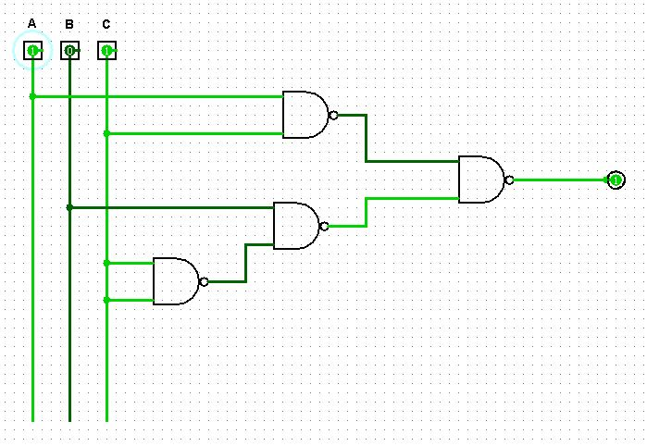

Figure: Logisim circuit schematic of Universal (NAND) gate implementation of the circuit of Figure D2

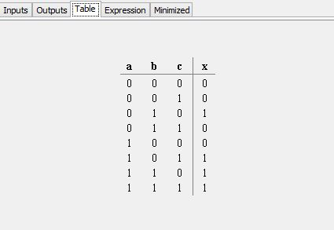

Figure: Truth table of Universal (NAND) gate implementation of the circuit of Figure D2

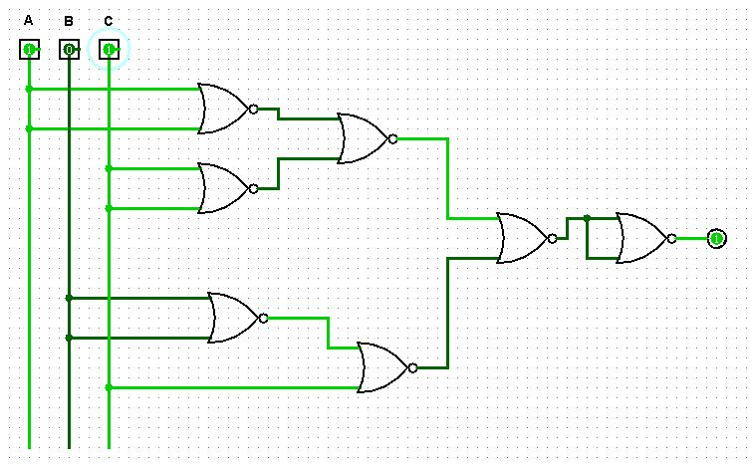

Figure: Logisim circuit schematic of Universal (NOR) gate implementation of the circuit of Figure D2

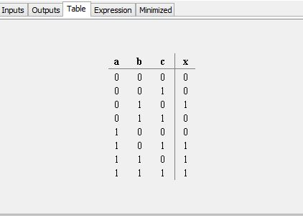

Figure: Truth table of Universal (NOR) gate implementation of the circuit of Figure D2